Functional Decomposition

Rui Gao

[gaorui@oregonstate.edu](mailto:gaorui@oregonstate.edu)

Project 3

CS 575

#1 What your own-choice quantity was and how it fits into the simulation.

Hunter. Maybe the hunter should kill more deer by setting the standard line lower because the influence made by hunters is small according to these graphs. The two categories’ number doesn’t move anymore…… But it also keep the amount of deer in a low level.

**#2 Simulations for 2021 – 2026**

Except pointed numbers, I tried to use hunter to kill exceed deer. The number under caught/ caught by hunters is the total number of deer that has been caught.

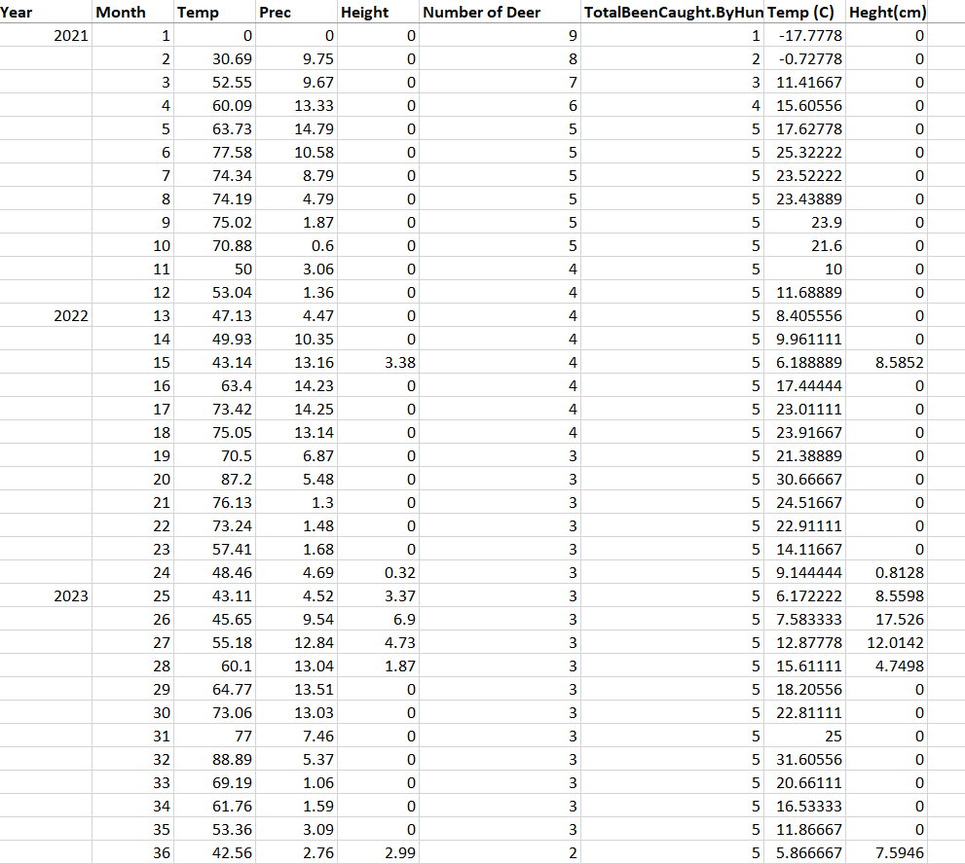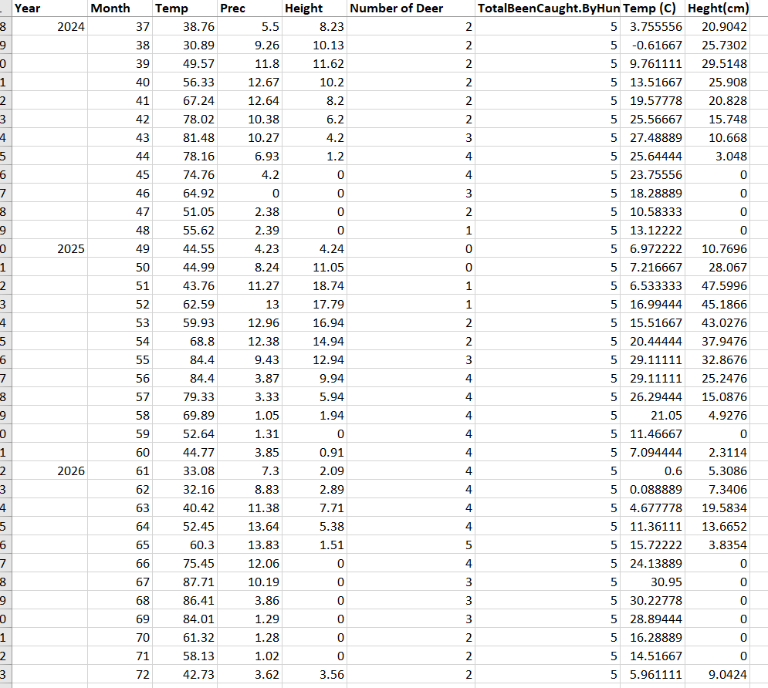

**#3 Tables, Graphs**

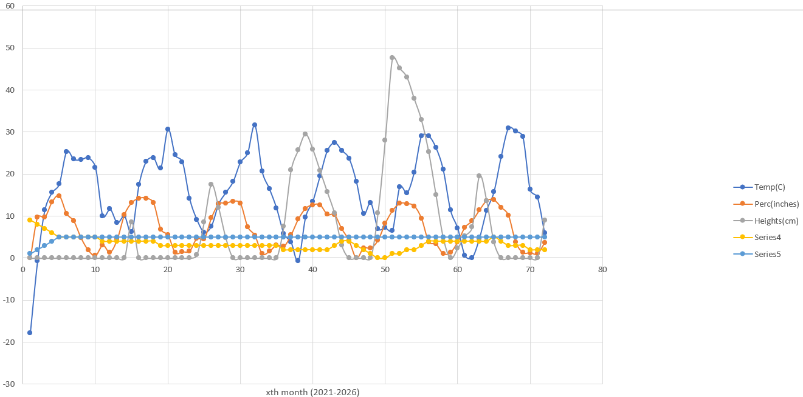

**#4 comments**

The Temp and Prec usually decrease after July and June and back in a new year. The height grows good at spring. However, once the number of deer grow, the height decreases rapidly even though the temp and prec still increasing. The humter also keeps the amount of deer in a low level.